B-6-5:
Mathlab Solution:

Program:
num=[0 0 0 0 1];
den=[1 4 11 14 10];
rlocus(num,den);
v=[-6 6 -6 6];
axis(v);
grid;
title('Root-Locus Plot of G(s)=K/[(s^2+2s+2)(s^2+2s+5)]')

Output:

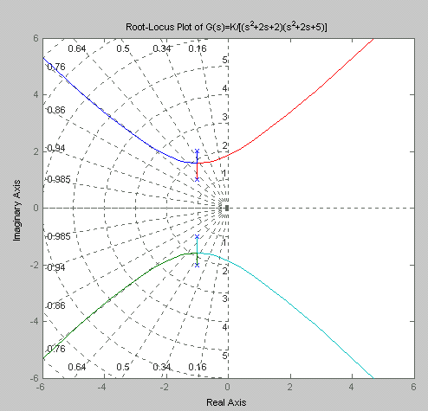

B-6-9:
Mathlab Solution:

Program:

num=[0 0 1 9];
den=[1 4 11 0];
rlocus(num,den);
v=[-10 10 -10 10];
axis(v);
grid;
title('Root-Locus Plot of G(s)=K(s+9)/[s(s^2+4s+11)]')

Output:

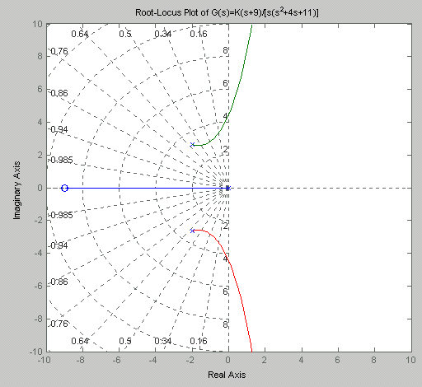

B-6-12:
Mathlab Solution:

Program:

num=[0 0 0 1 1];
den=[1 4 11 14 10];
rlocus(num,den);
v=[-6 6 -6 6];
axis(v);axis('square')
grid;
title('Root-Locus Plot of G(s)=K(s+1)/[(s^2+2s+2)(s^2+2s+5)]')

Output:

